Project Report: Analysis of Amazon Sales Data

**Introduction**

Sales management is crucial for commercial enterprises to remain competitive, reduce costs, and increase profits. This project aims to analyze Amazon sales data to identify trends, key metrics, and factors influencing sales performance. The project follows the Extract-Transform-Load (ETL) process to extract data from the dataset, transform it into a suitable format, and load it for analysis.

**1. Dataset**

* The dataset used for this analysis contains the following columns:
* Region
* Country
* Item Type
* Sales Channel
* Order Priority
* Order Date
* Order ID
* Ship Date
* Units Sold
* Unit Price
* Unit Cost
* Total Revenue
* Total Cost
* Total Profit

**2. Extract**

The dataset is loaded into a pandas DataFrame from a CSV file. Relevant columns including 'Order Date' and 'Total Revenue' are extracted.

**3. Transform**

'Order Date' column is converted to datetime format for easier manipulation. Month and year are extracted from the 'Order Date'. The data is aggregated month-wise and year-wise, calculating the sum of 'Total Revenue' for each period.

**4. Load**

The transformed data is loaded into suitable data structures for analysis.

**5. Analysis**

**Sales Trends**

* Monthly Sales Trend: The trend of total revenue over months, highlighting any seasonal patterns or changes.

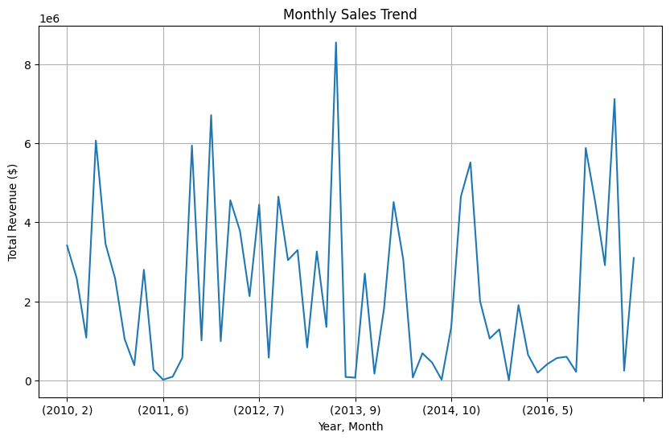

* Yearly Sales Trend: Total revenue for each year, identifying overall growth or decline in sales.

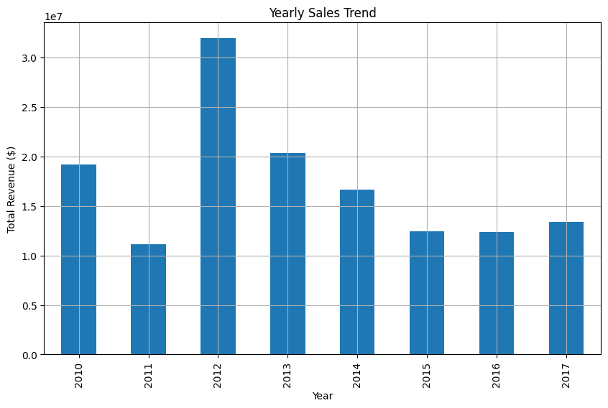

**Key Metrics and Factors**

* Region-wise Analysis: Identify which regions contribute the most to sales revenue.

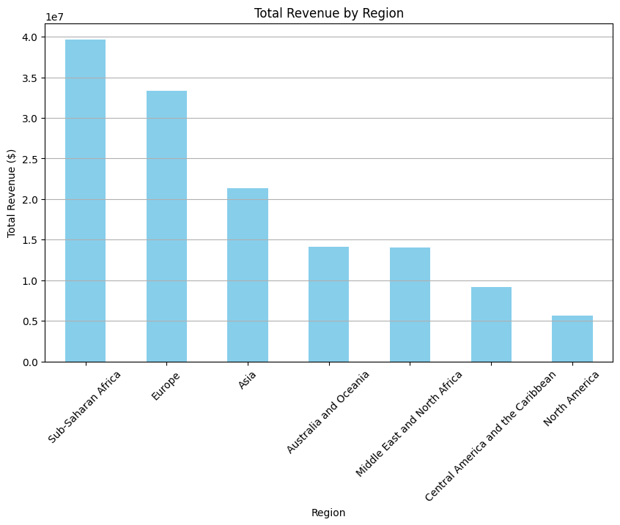

* Item Type Analysis: Determine which item types are most profitable.

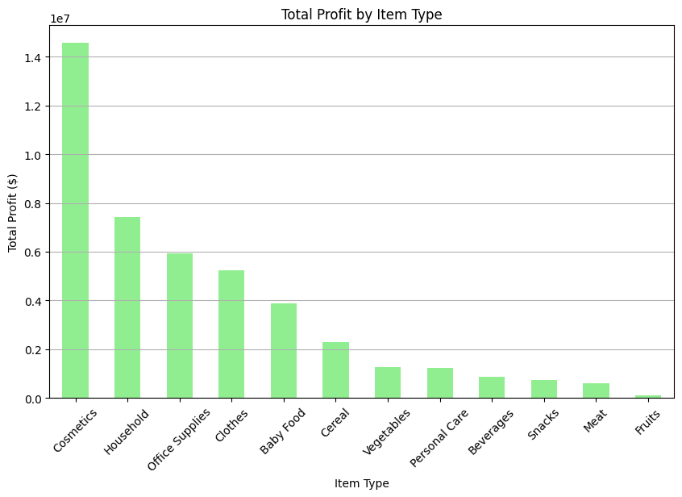

* Sales Channel Analysis: Analyze the performance of different sales channels.

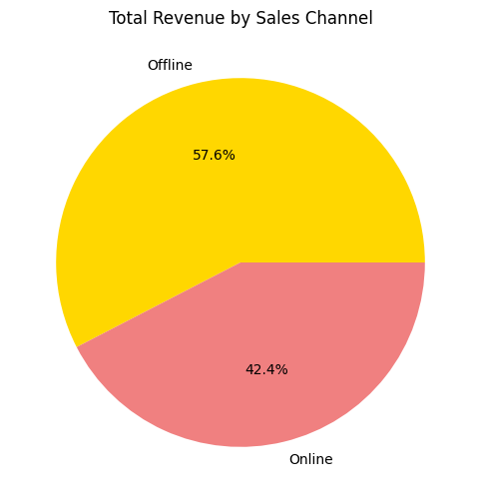

* Order Priority Analysis: Understand the impact of order priority on revenue.

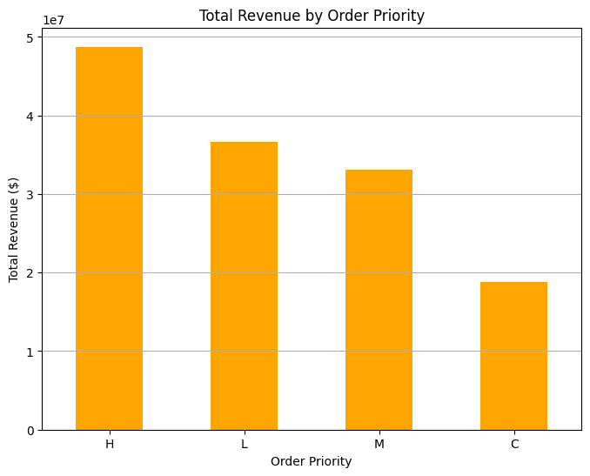

* Unit Price and Unit Cost Analysis: Examine the relationship between pricing and costs on revenue.

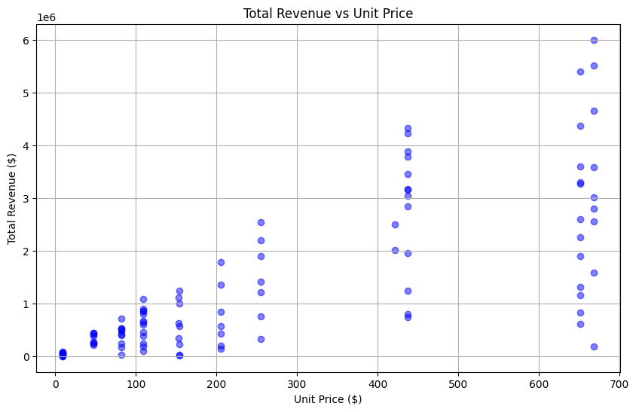

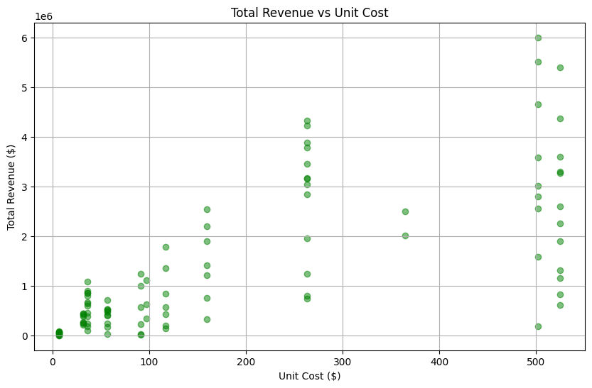

* Time-series Forecasting: Forecast future sales based on historical data using time-series analysis techniques.

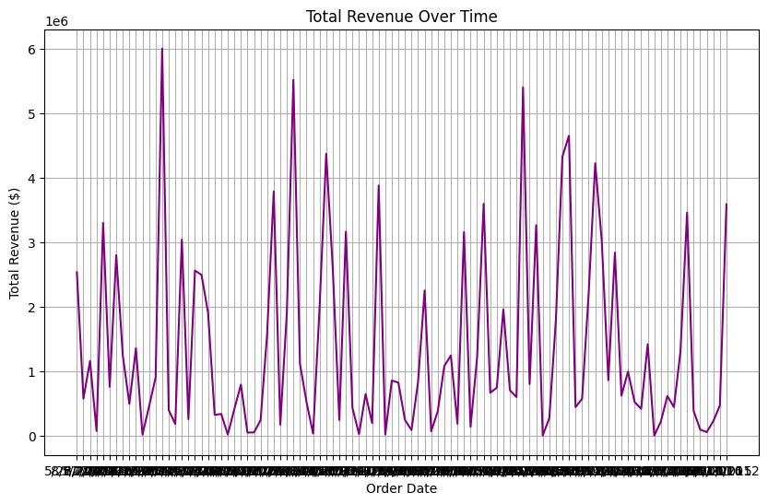

**Conclusion**

Amazon sales data analysis provides insights into sales trends, key metrics, and factors influencing revenue.

Understanding these insights can help optimize sales strategies, improve decision-making, and drive business growth.

This report outlines the process, analysis, and potential insights gained from analyzing Amazon sales data. Depending on specific requirements and business goals, further analysis and visualization techniques can be applied to extract more detailed insights.